**How does motor plasticity affect processing of concrete language and perception of distance?**

The aim of this study is to investigated whether motor movement does affect subsequent comprehension of language and estimation of distance. Therefore, I will conceptually replicate the study of Glenberg, Marc and Luigi (2008), who showed an interaction between hand movement and language comprehension. Moreover, I will test the robustness of the effect by including a task with cognitive load.

Previous research indicates that the motor cortex undergoes continuous plastic modification, that is, frequently repeated movements do strengthen network connection patterns (Cohen et al. 1996; Elbert et al. 1995). Already a brief performance of simple thumb movements does change neuronal patterns of the motor cortex (Classen et al., 1998). Moreover, an embodied approach to language proposes that humans use neural system that are usually engaged in perception and action, to understand language (Zwaan, 2004). For example, mirror neurons in the motor cortex become active, when actions are described verbally (Buccino, Binkofski, & Riggio, 2004; Tettamanti et al., 2005).

In this experiment, I will replicate the study by Glenberg, Marc and Luigi (2008) who showed that modification of the neural motor system does affect subsequent comprehension of language. The results indicate that the comprehension of subsequent sentences increases, when the described direction of the object transfer (e.g. You give Anna a pen) matches to the hand movement (e.g. You moved your hand away from your body). To induce repetition of hand movements either away or towards the participant’s body, they first asked participants to move beans from one container to a target container for approx. 15 minutes. Afterwards participants read nonsense or sensible sentences describing transfer of objects towards or away from themselves. The study showed an interaction between the direction of bean movement and the direction of described transfer of the sentences. That is, if you moved the beans towards yourself, you will make quicker responses to sentences that indicate an object transfer towards you (e.g. Tim gives you a pen), whereas movements away from you lead to quicker comprehension of sentences that describe an object transfer away from you (e.g. You give Tim a pen).

I will manipulate motor movement in such a way that it can be administered via a computer. Afterwards, I will administer a language comprehension task, as well as, an estimation of distance.

**H1:** Does motor movement towards/away from the participant increase the comprehension of statements directed towards/away from the participant?

**H2**: Do these effects continue to exist under cognitive load and with irregular motor movement?

**H3:** Does motor movement towards/away change the estimation of distance (further away/further towards)?

**H4**: Is the direction of the distance estimation(up/down) influenced by the direction of the motor movement (away/towards).

**Method**

I will use a 2 (away/towards) x 2 (constant/cognitive load) between subject’s design. The participants must either move an object away or towards their body, and they either have to constantly move an object or have to move an object under cognitive load.

Motor movement will be manipulated by asking participant to move a circle located in the upper/lower part of the screen towards a container in lower/upper part of the screen, via a computer mouse. This should translate in a hand movement either towards the participant or away from the participant (see Figure 1).

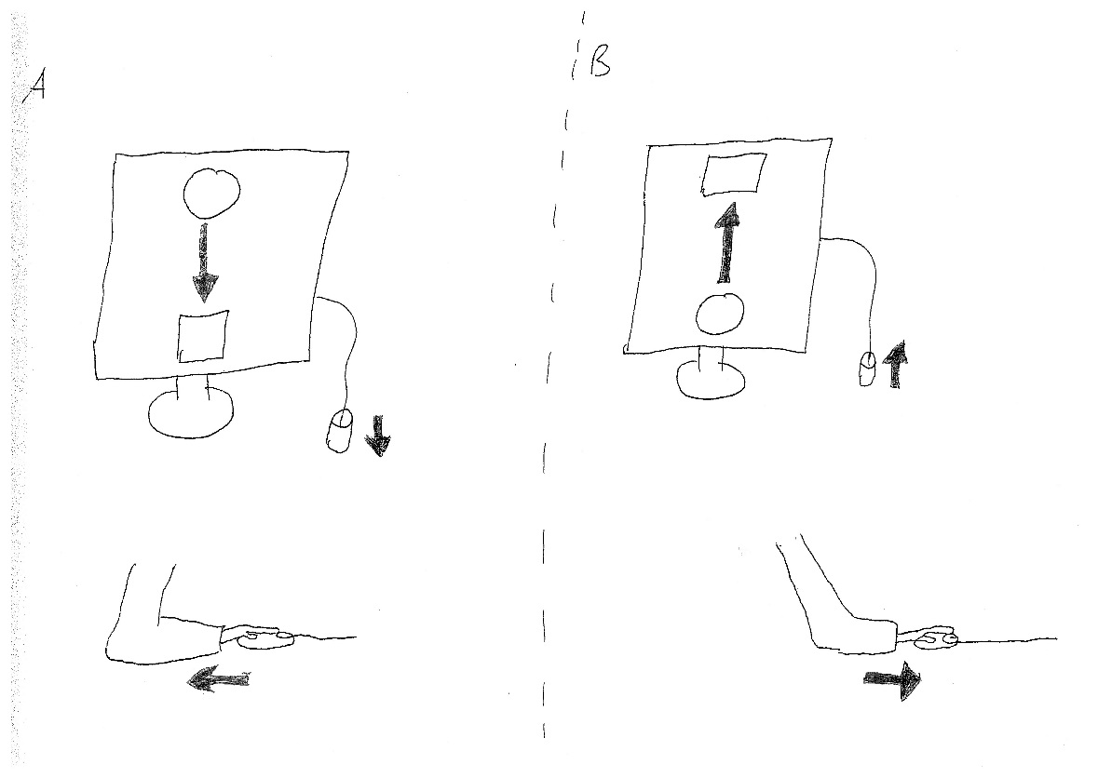

*Figure 1:* On the left side, the motor movement is induced towards one’s body, by dragging the object to the lower part of the screen. On the right side, the motor movement is induced away from one’s body, by dragging the object to the upper part of the screen.

This task should simulate the bean movement task by Glenberg, Marc and Luigi (2008). To induce a constant motor movement participants will be told that they can win a price when they gain a high-score. Additionally, cognitive load and irregular movement will be induced by constantly changing the shown symbol, the participants will only get a point when she/he moves the correct symbol, a circle.

In the second part of the experiment, every participant will be asked to judge sentences, by pressing either the “K” button (Sensible) or the “L” Button (Nonsensible) with their right index finger. The sentences are either directed away (e.g. You give Peter a pen) or towards the participant (e.g. Peter gives you a pen) and are either sensible (e.g. You give Anna a pizza) or nonsensible (e.g. Anna you pizza give). Sentence comprehension will be measured by two dependent variables for each sentence type: the time it took the participants to respond to the sentence, as well as the ratio with which the participant is judging the sentence correctly to be sensible or nonsensible.

In the third part of the experiment, distance will be measured via a task, in which the participant must place a ball a given distance away from the centre of the screen. We will measure whether people estimated the distance further away/closer to the centre of the screen when they previously made a hand movement (via mouse) away/towards their body. Additionally, the global direction of the estimation is measured, so how often the ball was placed in the upper/lower part of the screen.

**Experimenter’s manual**:

Please first make sure that all files that are given in Table 1 are in the same folder as the main program “Ass_3_20170306”. This is important, otherwise the program will not work properly. Before you start the program make sure that the PC’s monitor is set to 96 dpi (dots per inch). For a detailed manual visit: http://www.dummies.com/computers/pcs/change-your-monitors-dots-per-inch-dpi-setting/

Start the program by opening the file “Ass_3_20170306”, a program called PYCharm will open, this can take a while, so make sure you do it before participants arrive. When the participant arrived click on the green play symbol in the upper right corner of the screen, see Figure 2.

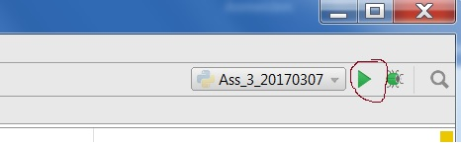

*Figure 2*: Play Symbol

After a participant finished you will return to the PyCharm screen, to start the next trial with a participant you must click on the green play symbol again.

The output of the experiment can be found in the .csv file “SPSSfile” in the same folder as the main program. An explanation of the variable can be found in Table 2. The input file that is needed for the sentences is in a .csv file called “Stimuli”, the first four sentences are for the test trial, the rest of the sentences are for the real trial.

Moreover, the experiment includes the chance to win 50 £, thus a participant can write in his/her e-mail (if they want to participate). The file that stores the necessary variables is called “EmailList” (.csv file) and can be found in the same folder as the main program, see Table 3 for a more detailed explanation of the variables. There are two winners: one person with the highest score in the cognitive and one person with the highest score in the neutral condition (to make it fair).

The experimental procedure will be explained in detail to the participant by the program. The cover story is that this will be newly developed test of cognitive abilities.

There are five important points you have to consider:

1. It is very important that you keep an eye on people, so they use their right hand for each task. Also, they must only use their right index finger for the sentence comprehension task. (This is important due to changes in the located in the left inferior frontal and parietal region that represent motor movement of the right body side)
2. Stress that there is a chance to win 50 £, for the person with the highest score in the motor persistence task (the motor movement manipulation).
3. Keep the cover story that this is a new test of cognitive abilities. After participants have finished, you should debrief them and explain them the real reasons of the experiment.
4. Do not make any changes to the files, always keep all the files in Table 1 in the same folder.
5. Before you start the program make sure that the PC’s monitor is set to 96 dpi (dots per inch). See: http://www.dummies.com/computers/pcs/change-your-monitors-dots-per-inch-dpi-setting/

|  |  |
| --- | --- |
| **Data** | **Explanation** |
| **Main program** |  |
| Ass_3_20170306 | This contains the main program (python code) |
| ExtraClasses | This is an extra python code |
| Ass3V9 | This is an extra python code |
| **Output Files** | This files appear after the first run |
| SPSSfile | This contains the output |
| EmailList | This contains the email list of the participants |
| **Input Files** |  |
| Stimuli | This contains the sentences of the experiment |
| **Images** | All the images used in the program |
| 1cm |  |
| ExpBox |  |
| ExpCircle |  |
| ExpCircleGhost |  |
| ExpKButton |  |
| ExpLButton |  |
| ExpQuadrat |  |
| ExpRightIndexFinger |  |
| ExpTriangle |  |
| LeftMouseButton |  |
| MouseCursor |  |
| UCLLogo |  |

*Table 1*: All these files need to be in the same folder as the main program

|  |  |  |
| --- | --- | --- |
| **VariableNames** | **Output** |  |
| **Independent Variables** |  |  |
| CondAwayTowads | 0|1 | 0 = Move symbol away from body|1 = Move symbol towards body |
| CondCognitiveNeutral | 0|1 | 0 = Symbols change, cognitive load|1 = No symbol change, neutral |
| **Dependent Variables** |  |  |
| **Language Comprehension** |  |  |
| CorrectSensibleTo | 1-0 | Percentage of how many sensible sentences that describe object transfer towards person are judged correct |
| RTSensibleTo | 0-… | Reaction Time in milliseconds (ms) how long subject needed to answer a sensible sentence with object transfer towards oneself |
| CorrectSensibleAway | 1-0 | Percentage of how many sensible sentences that describe object transfer away from person are judged correct |
| RTSensibleAway | 0-… | Reaction Time in ms how long subject needed to answer a sensible sentence with object transfer away from oneself |
| CorrectNonsensibleTo | 1-0 | Percentage of how many nonsensible sentences that describe object transfer towards person are judged correct |
| RTNonsensibleTo | 0-… | Reaction Time in ms how long subject needed to answer a sensible sentence with object transfer towards person |
| CorrectNonsensibleAway | 1-0 | Percentage of how many sensible sentences that describe object transfer away from person are judged correct |
| TimeNonsensibleAway | 0-… | Reaction Time in ms how long subject needed to answer a nonsensible sentence with object transfer away from oneself |
| **Distance Estimation Task** |  |  |
| AverageDistance | 0-15 | Average of all distance estimations in cm |
| PercentageUp | 1-0 | Percentage of how often the ball has been placed in upper half of screen |
| PercentageDown | 1-0 | Percentage of how often the ball has been placed in lower half of screen |

*Table 2*: Independent and dependent Variables in output file “SPSSFile”

|  |  |  |
| --- | --- | --- |
| **Variable** | **Possible Outcome** | **Explanation** |
| TotalCount | 0-… | This number shows how many times the participant has dropped the circle into the box within the given time |
| CondCognitiveNeutral | 0|1 | 0 = Cognitive load (symbols changed) 1 = Neutral, the same symbol every time |
| EmailAddress | string | This is the E-Mail address of the participant |

*Table 3*: The variables given in “EmailList”

**Program highlights:**

1. To simulate a motor movement, I had to come up with a procedure that simulates a physical movement when using a computer (see Figure 1).
2. I created 5 custom widgets: 1. A QLabel that can be dragged and dropped, as well as continuous changing its symbols, 2. A QLabel which can be dropped into, 3. A QLabel that can be moved (and appears at the focus of the mouse click, the draggable ball), 4. A QWidget that can be dropped into, 5. A QWidget that reacts to a keyboard input
3. I created a precise measure of how much time it took the participants to answer by subtracting the system time at the beginning and end of each stimuli.
4. The stimuli can be comfortably changed (e.g. via excel), the program does accept that researcher adds, subtracts or changes (if she/he did a typo) stimuli.
5. There are test trials, which gives a detailed feedback (whether general decision was correct, and whether person was in time!) and animations to increase participants understanding of the experimental procedures.
6. The conditions are decided by bitwise coding of the two independent variables.

**References**

Buccino, G., Binkofski, F., & Riggio, L. (2004). Brain and Language, 2004, Vol.89(2), pp.370-376; The mirror neuron system and action recognition. *Brain and Language, 89*(2), 370-376. doi:10.1016/S0093-934X(03)00356-0

Classen, J., Liepert, J., Wise, S. P., Hallett, M., & Cohen, L. G. (1998). Journal of neurophysiology, February 1998, Vol.79(2), pp.1117-23; Rapid plasticity of human cortical movement representation induced by practice. *Journal of Neurophysiology, 79*(2), 1117.

Cohen, L., Gerloff, C., Faiz, L., Uenishi, N., Classen, J., Liepert, J., & Hallett, M. (1996). Directional modulation of motor cortex plasticity induced by synchronicity of motor outputs in humans. *Soc Neurosci Abstr, , 22* 1452.

Elbert, T., Pantev, C., Wienbruch, C., Rockstroh, B., & Taub, E. (1995). Science, 13 October 1995, Vol.270(5234), pp.305-307; Increased Cortical Representation of the Fingers of the Left Hand in String Players. *Science, 270*(5234), 305-307.

Glenberg, A. M., Sato, M., & Cattaneo, L. (2008). *Current Biology, 2008, Vol.18(7), pp.R290-R291; Use- induced motor plasticity affects the processing of abstract and concrete language* doi:10.1016/j.cub.2008.02.036

Tettamanti, M., Buccino, G., Saccuman, M. C., Gallese, V., Danna, M., Scifo, P., . . . Perani, D. (2005). Journal of Cognitive Neuroscience, 2005, Vol.17(2), pp.273-281; Listening to Action- related Sentences Activates Fronto- parietal Motor Circuits. *Journal of Cognitive Neuroscience, 17*(2), 273-281. doi:10.1162/0898929053124965

Zwaan, R. (2004). Psychology Of Learning And Motivation: Advances In Research And Theory, Vol, 2004, pp.35-62; The immersed experiencer: Toward an embodied theory of language comprehension. *Psychology of Learning and Motivation: Advances in Research and Theory, Vol, 44*, 35-62.